**M6_2_Assignment_Joining_Data.**

**Chrissie Raj**

**G01465544**

### **Instructions**

**Practice Problems Instructions:**

**When working with a database, it is important to know what tables it contains. It is also essential to have information about the structure of each table, including column names, data types, constraints, etc. to retrieve data. This kind of information (and much more!) can be found in the data dictionary, which is a collection of read-only tables that contain metadata, or data about the database.**

**See more on the** [**data dictionary here**](https://docs.oracle.com/en/database/oracle/oracle-database/19/cncpt/data-dictionary-and-dynamic-performance-views.html#GUID-BDF5B748-EB43-4B48-938E-89099069C3BB)**.**

**Use the following commands to obtain information about the tables in the database:**

* **select table_name from user_tables; /* to display a list of tables */**
* **select * from all_tab_columns where table_name='table_name'; /* to display the structure of a table */**
* **select * from table_name; /* to display the content of a table */**

**In the commands above, substitute *table_name* with the actual name of the table. If '*table_name*' is enclosed in single quotation marks, the name of the table must be entered in capital letters.**

**Important Note:**

**For the practice problems below, follow examples shown in the PowerPoint presentations and textbooks but do not copy their solutions unless it is the only possible answer to the problem.**

**General Instructions:**

**The practice problems are arranged in order of increasing difficulty – the last several problems in each section might present the most challenge. Students are expected to work out and submit the solutions to at least 5 problems in each section. If you have previous experience in SQL you can select the 5 most challenging problems in each section though it is still recommended to complete all problems. This will help you be better prepared for the Midterm and Final Exams. Challenge yourself to complete all problems!**

**Instructions: For each problem**

* **Write and execute an SQL query in Oracle Live SQL or SQL*Plus**
* **Execute the following command: select sysdate, '*your name*' from dual; where *your_name* is substituted with your name**
* **Take a screenshot that includes both SQL statements and all results**
* **Copy and paste the screenshot into a Word file containing your solutions**

**1) Practice Problems: Selecting Single-Row Functions**

***Before starting these problems, update the JustLee Books database by executing the JLDB_Build_Extended.sql script. You can find the script in the "Class Databases" folder.***

* **Write an SQL query to display a text string 'your_first_name your_last_name' that represents your full name. Then, use the INSTR function to determine the position of the single blank space in the text string 'your_first_name your_last_name'. Use the DUAL table.**
* **Use the SUBSTR function to extract a substring that represents your last name from the text string 'your_first_name your_last_name'. Assume you know the number of characters you need to extract.**
* **Use the INSTR and SUBSTR functions to extract a substring that represents your first name from the text string 'your_first_name your_last_name'. Assume you do not know the number of characters to extract.**
* **Use the INSTR, SUBSTR, and LENGTH functions to extract a substring that represents your last name from the text string 'your_first_name your_last_name'. Assume you do not know the number of characters you need to extract.**
* **Retrieve a list of all book titles along with authors’ names displayed as a single string ‘Last name, First name’ using the CONCAT function. In addition, also display the percentage of markup for each book as a whole number followed by a percent sign (for example, .2793 = 28%). The percentage of markup should reflect the difference between the retail and cost amount as a percent of the cost.**
* **Using today's date, determine the age (in months) of each book that JustLee sells. Make sure only whole months are displayed; ignore any portions of months. Display the book title, publication date, current date, and age.**
* **Create a list of all customer numbers along with text indicating whether the customer has been referred by another customer. Display the text "NOT REFERRED" if the customer wasn't referred to JustLee Books by another customer or "REFERRED" if the customer was referred.**
* **Determine the amount of total profit generated by the book purchased on order 1002. Display the book title and profit. The profit should be formatted to display a dollar sign and two decimal places. Take into account that the customer might not pay the full retail price, and each item ordered can involve multiple copies.**
* **Management is proposing to increase the price of each book. The amount of the increase will be based on each book’s category, according to the following scale: Computer books, 10%; Fitness books, 15%; Self-Help books, 25%; all other categories, 3%. Create a list that displays each book’s title, category, current retail price, and revised retail price. The prices should be displayed with two decimal places. The column headings for the output should be as follows: Title, Category, Current Price, and Revised Price. Sort the results by category. If there’s more than one book in a category, a secondary sort should be performed on the book’s title.**
* **Write a complex SQL query that is based on three or more tables and includes multiple nested single-row functions. Explain in a complete, coherent sentence what they query is intended to do.**

**2) Practice Problems: Group Functions**

***Before starting these problems, update the JustLee Books database by executing the JLDB_Build_Extended.sql script. You can find the script in the "Class Databases" folder.***

* **What's the retail price of the most expensive book written by Sam Smith?**
* **Determine the total profit generated by sales per customer. Note: Quantity should be reflected in the total profit calculation.**
* **Modify problem 2 to include only those customers who live in FL.**
* **Modify problem 3 to display the results with profit greater than $50.**
* **Determine the average retail price of books by publisher name and category. Include only the categories Children and Computer and the groups with an average retail price greater than $50.**

**SOLUTION:** This assignment involves solving SQL practice problems using the JustLee Books database. The objective is to apply SQL functions such as single-row functions and group functions, and to execute queries that calculate specific business metrics such as total profit, price adjustments, and customer referral status. Additionally, the goal is to practice working with complex SQL queries involving multiple tables and nested functions.

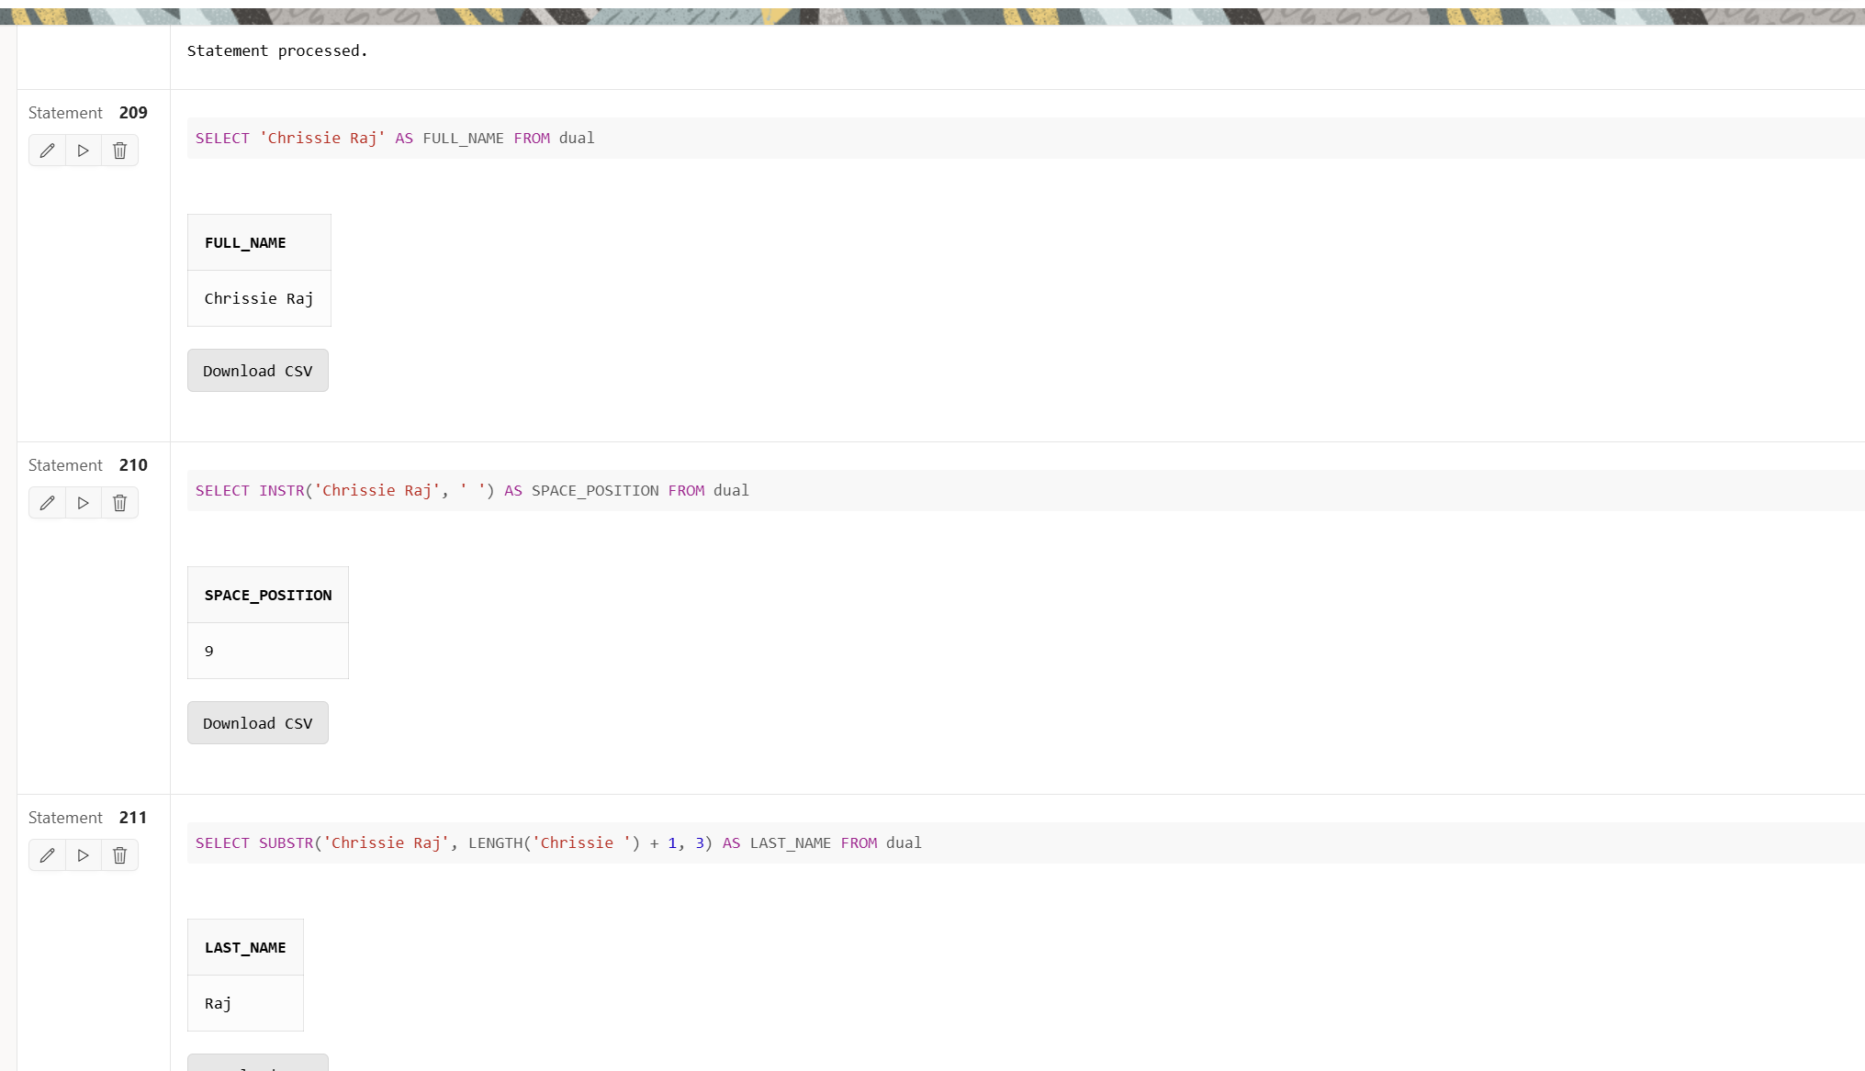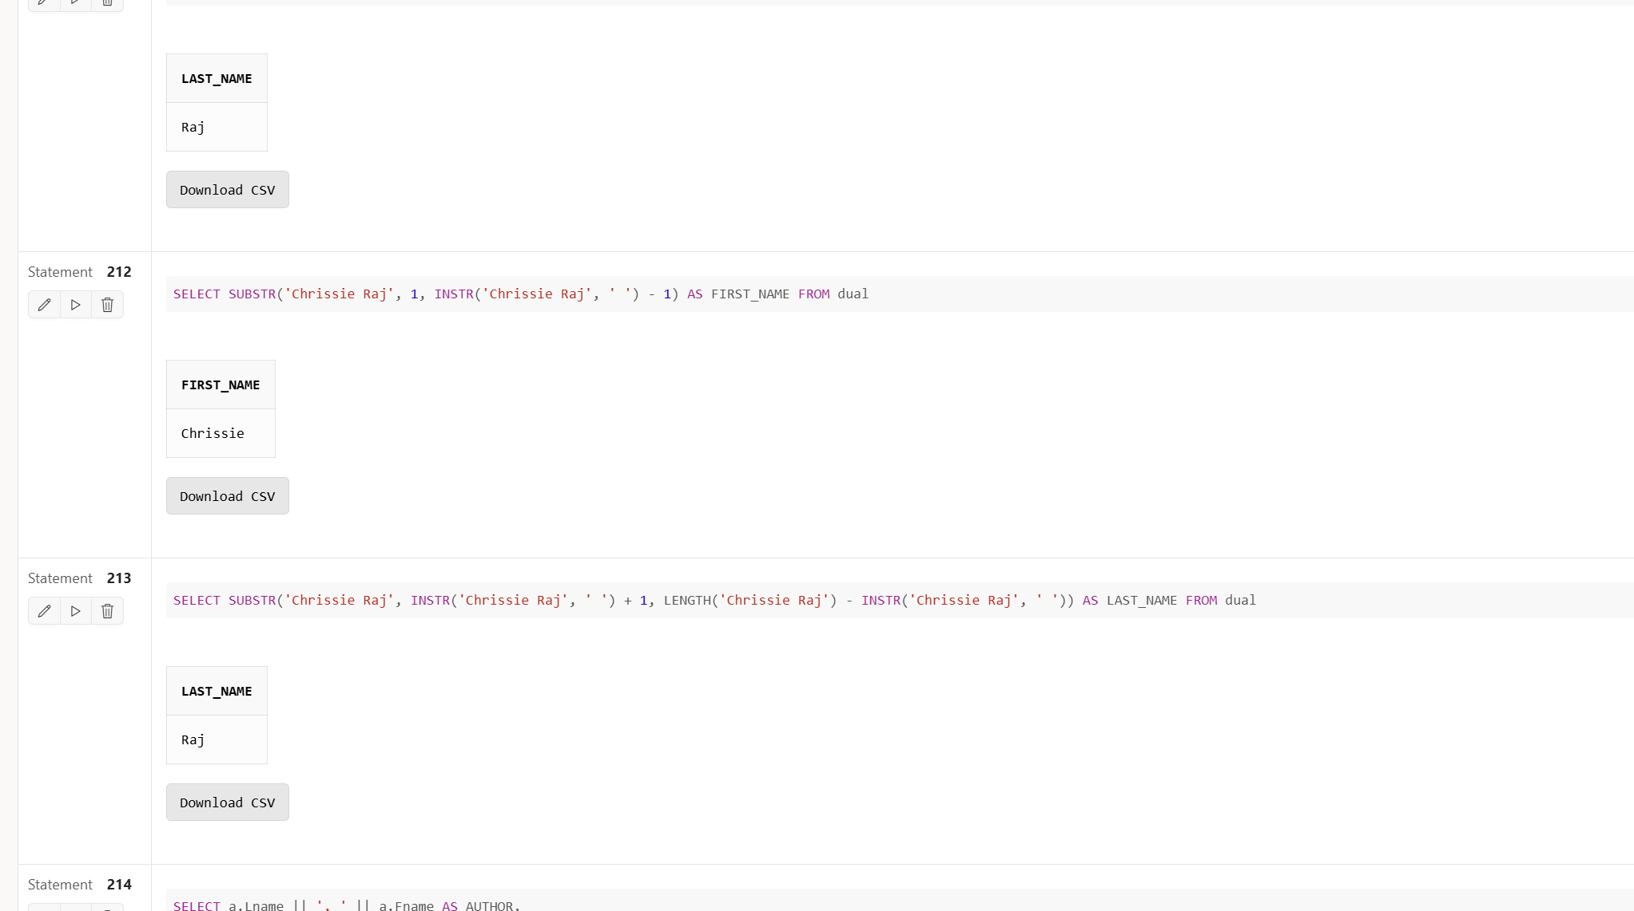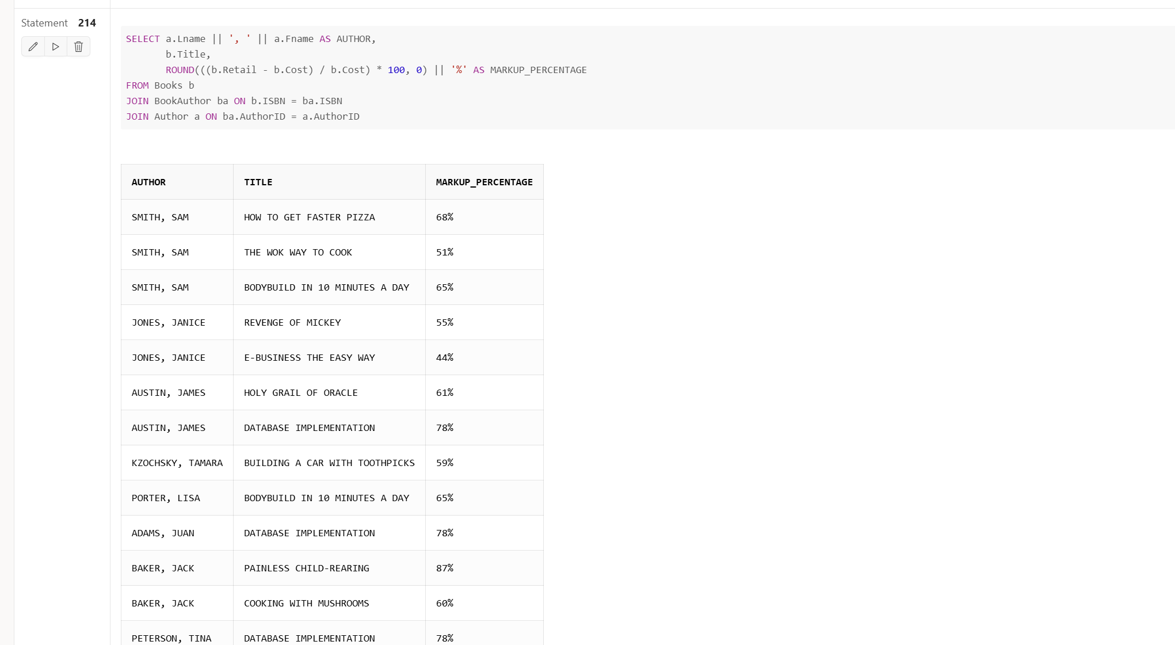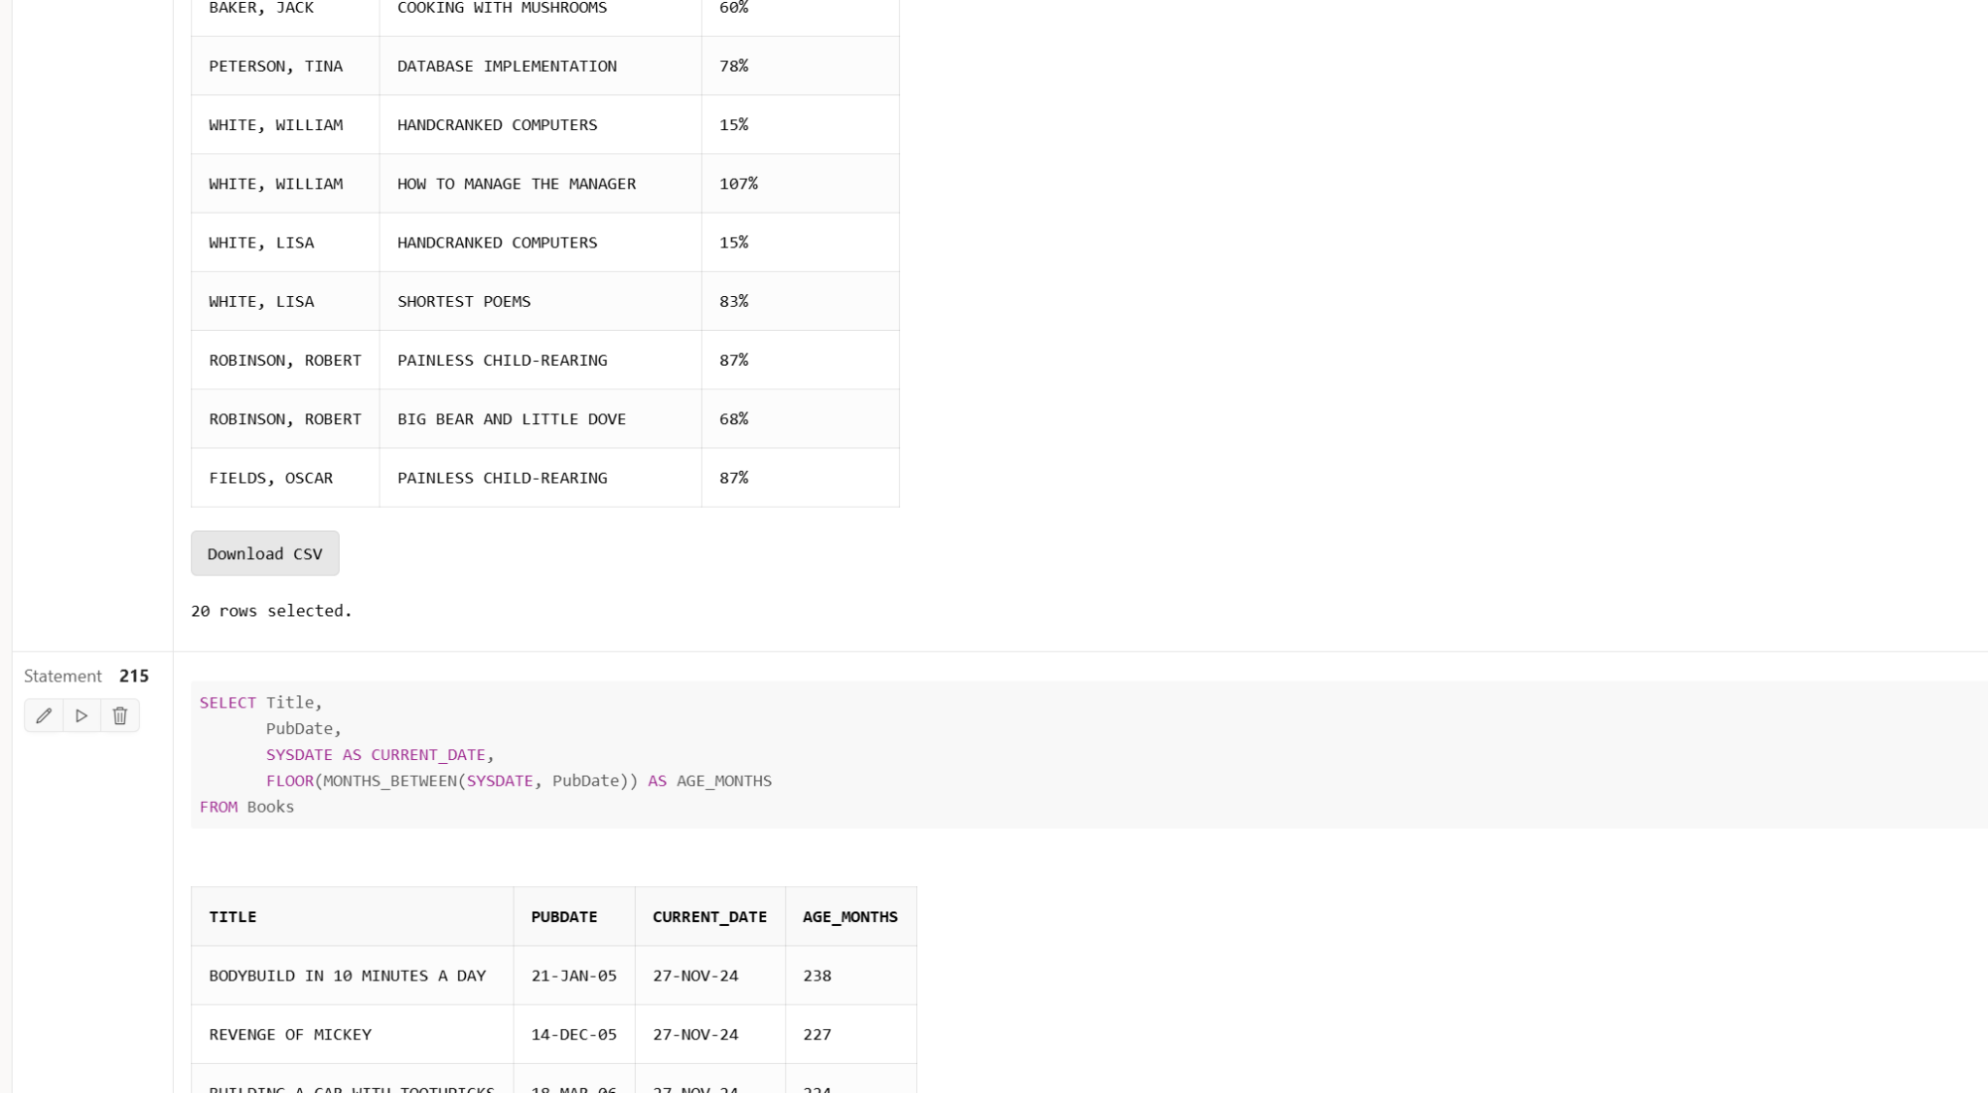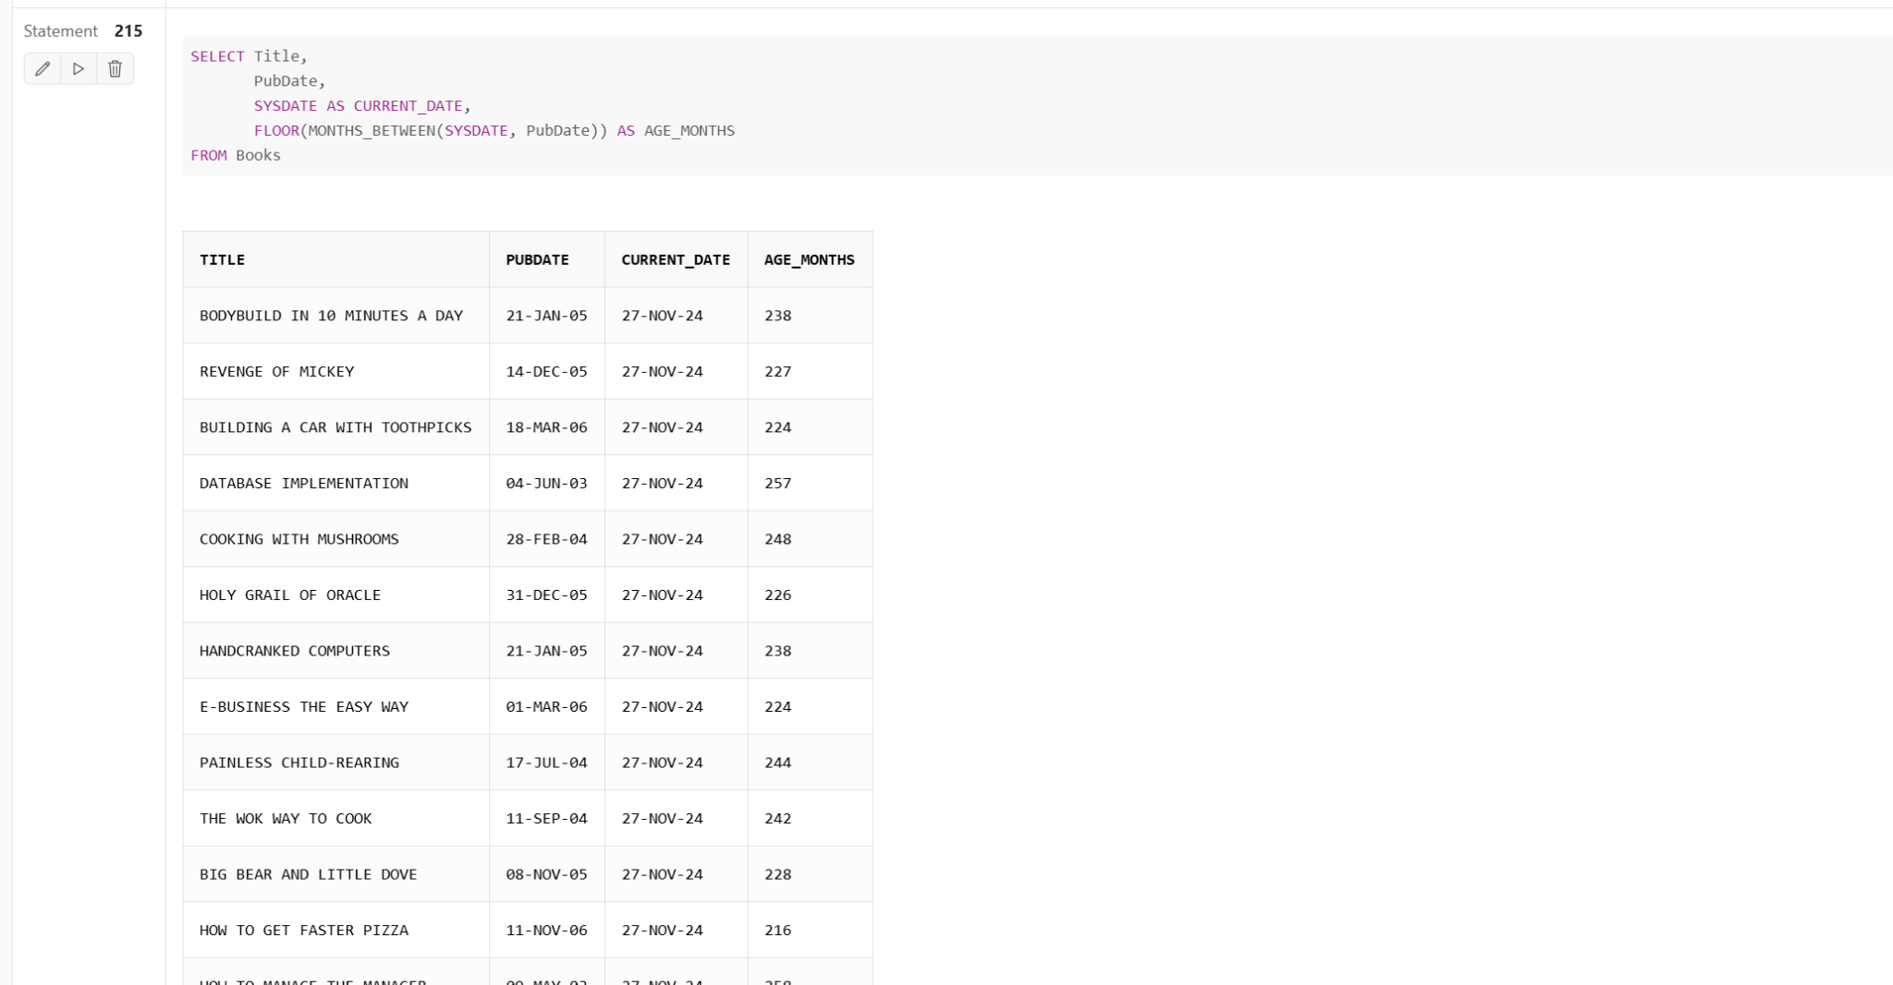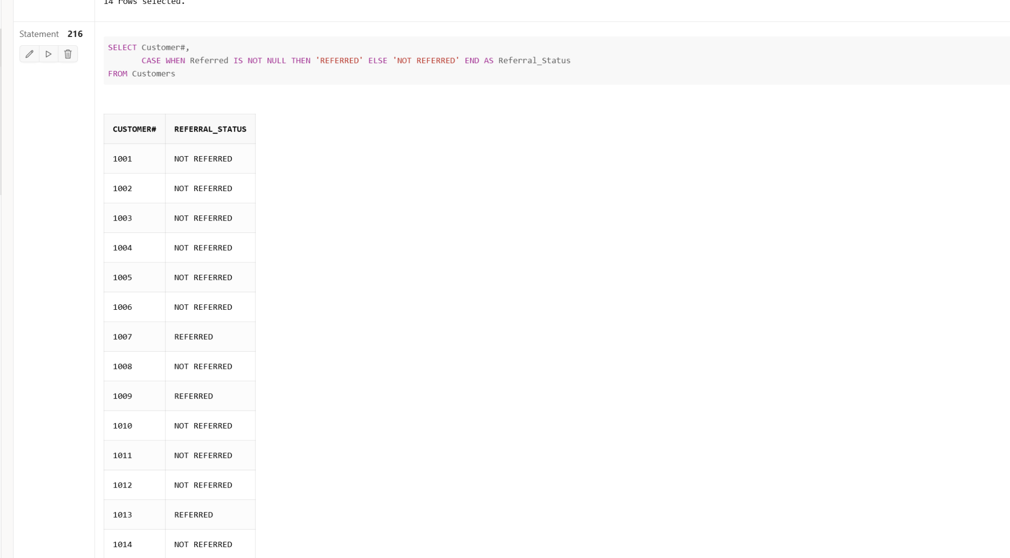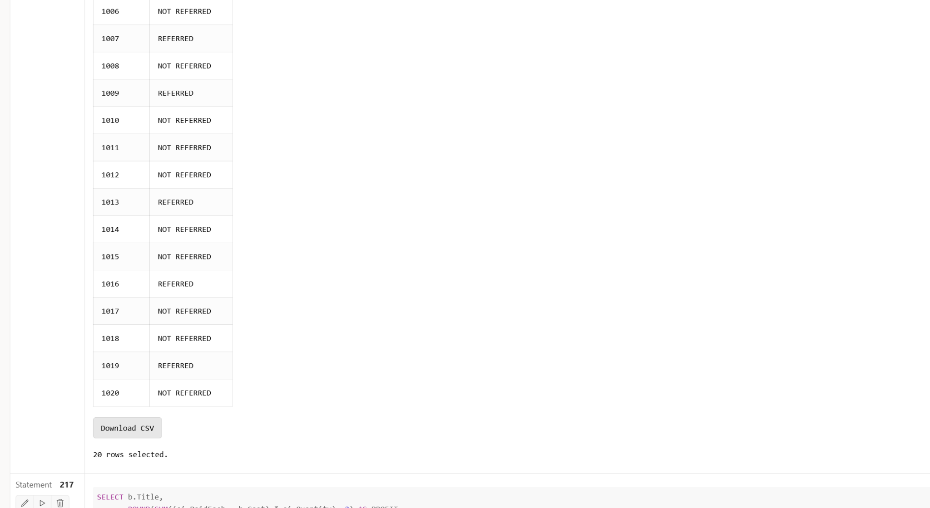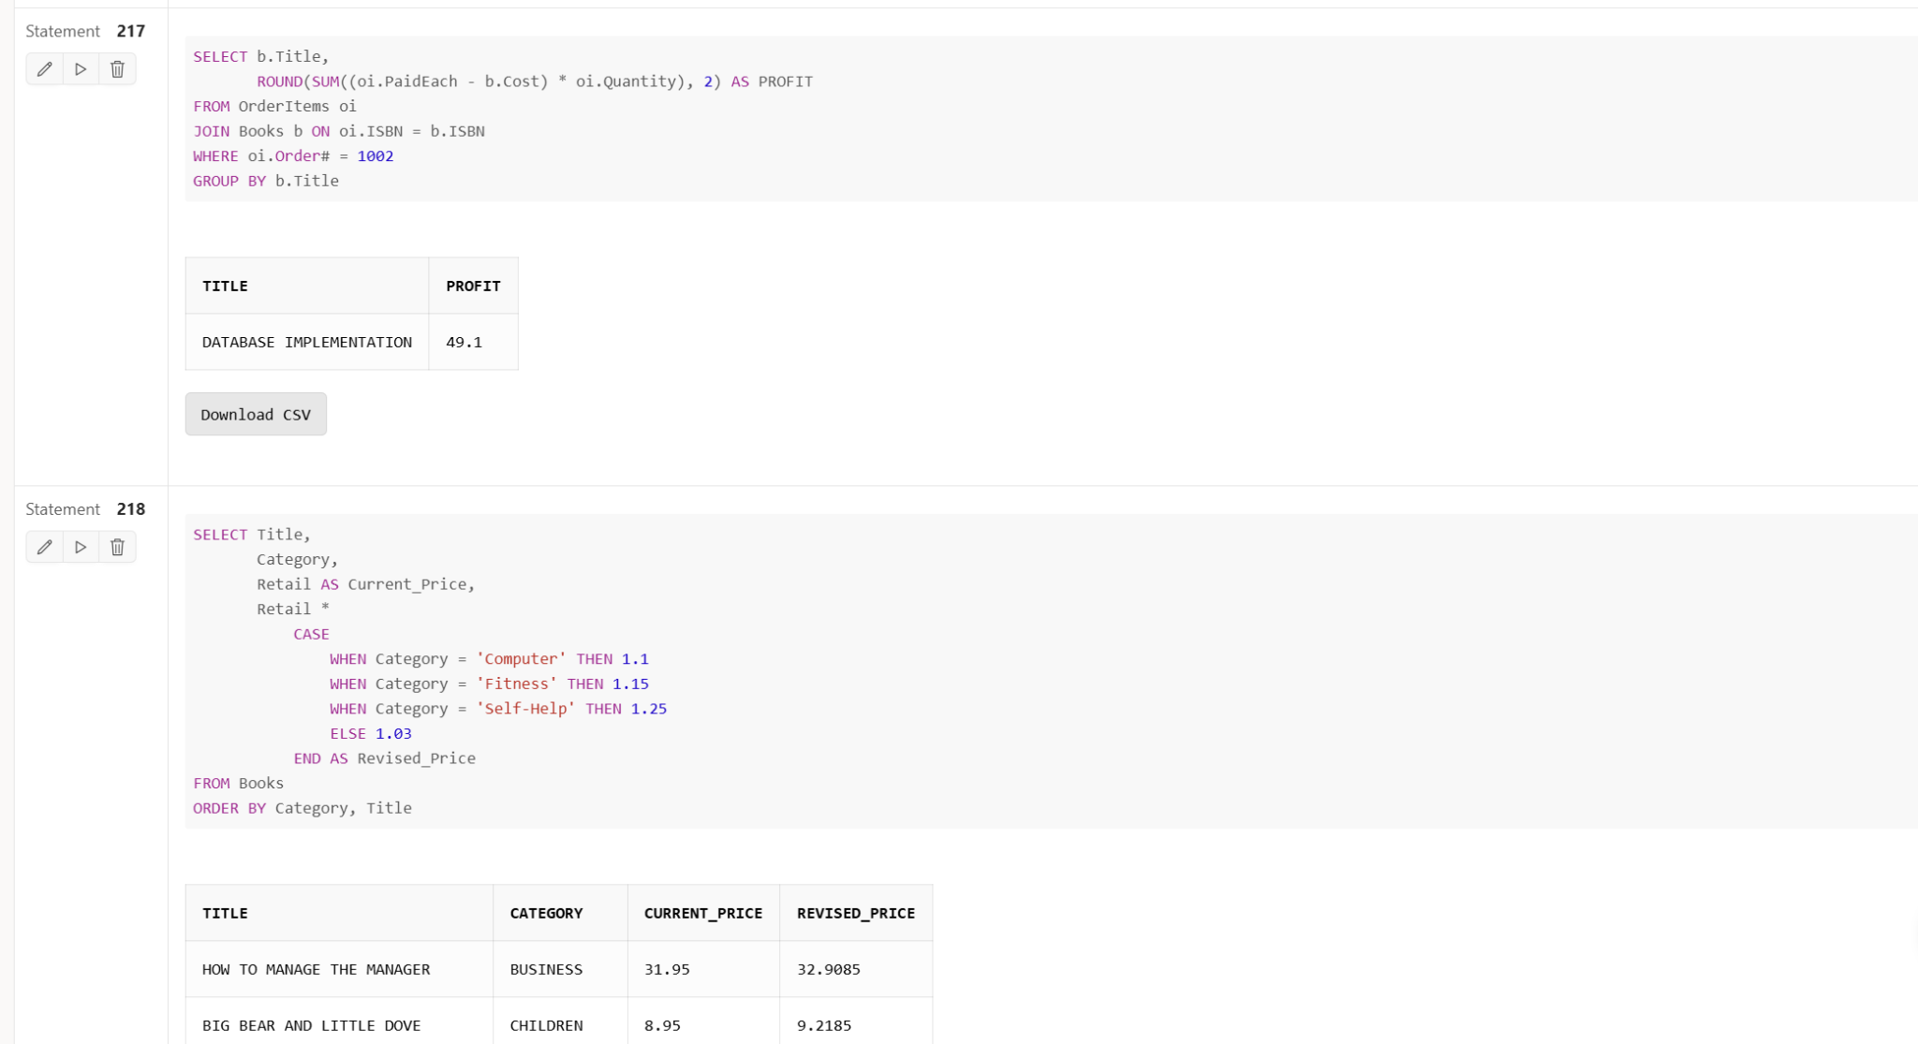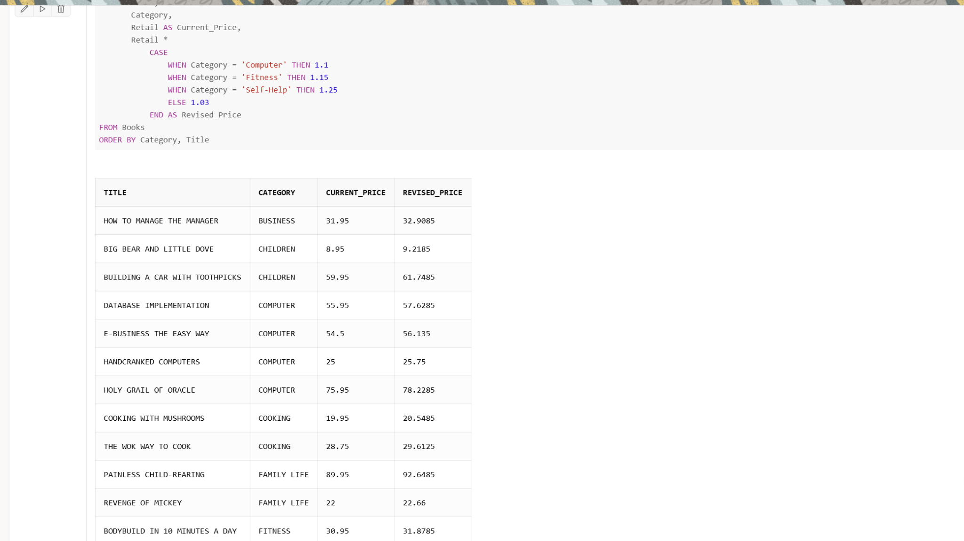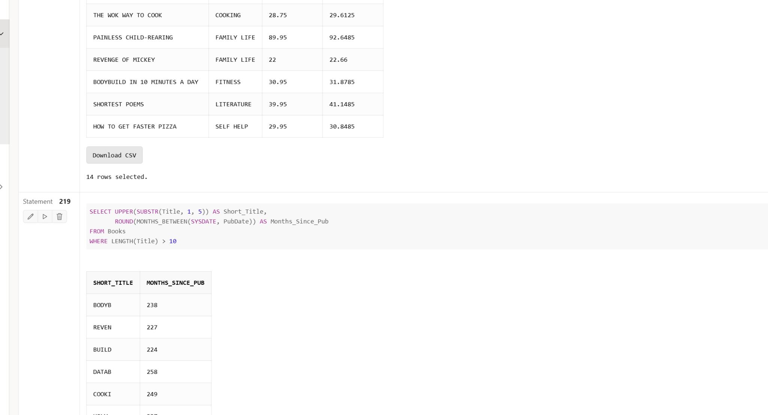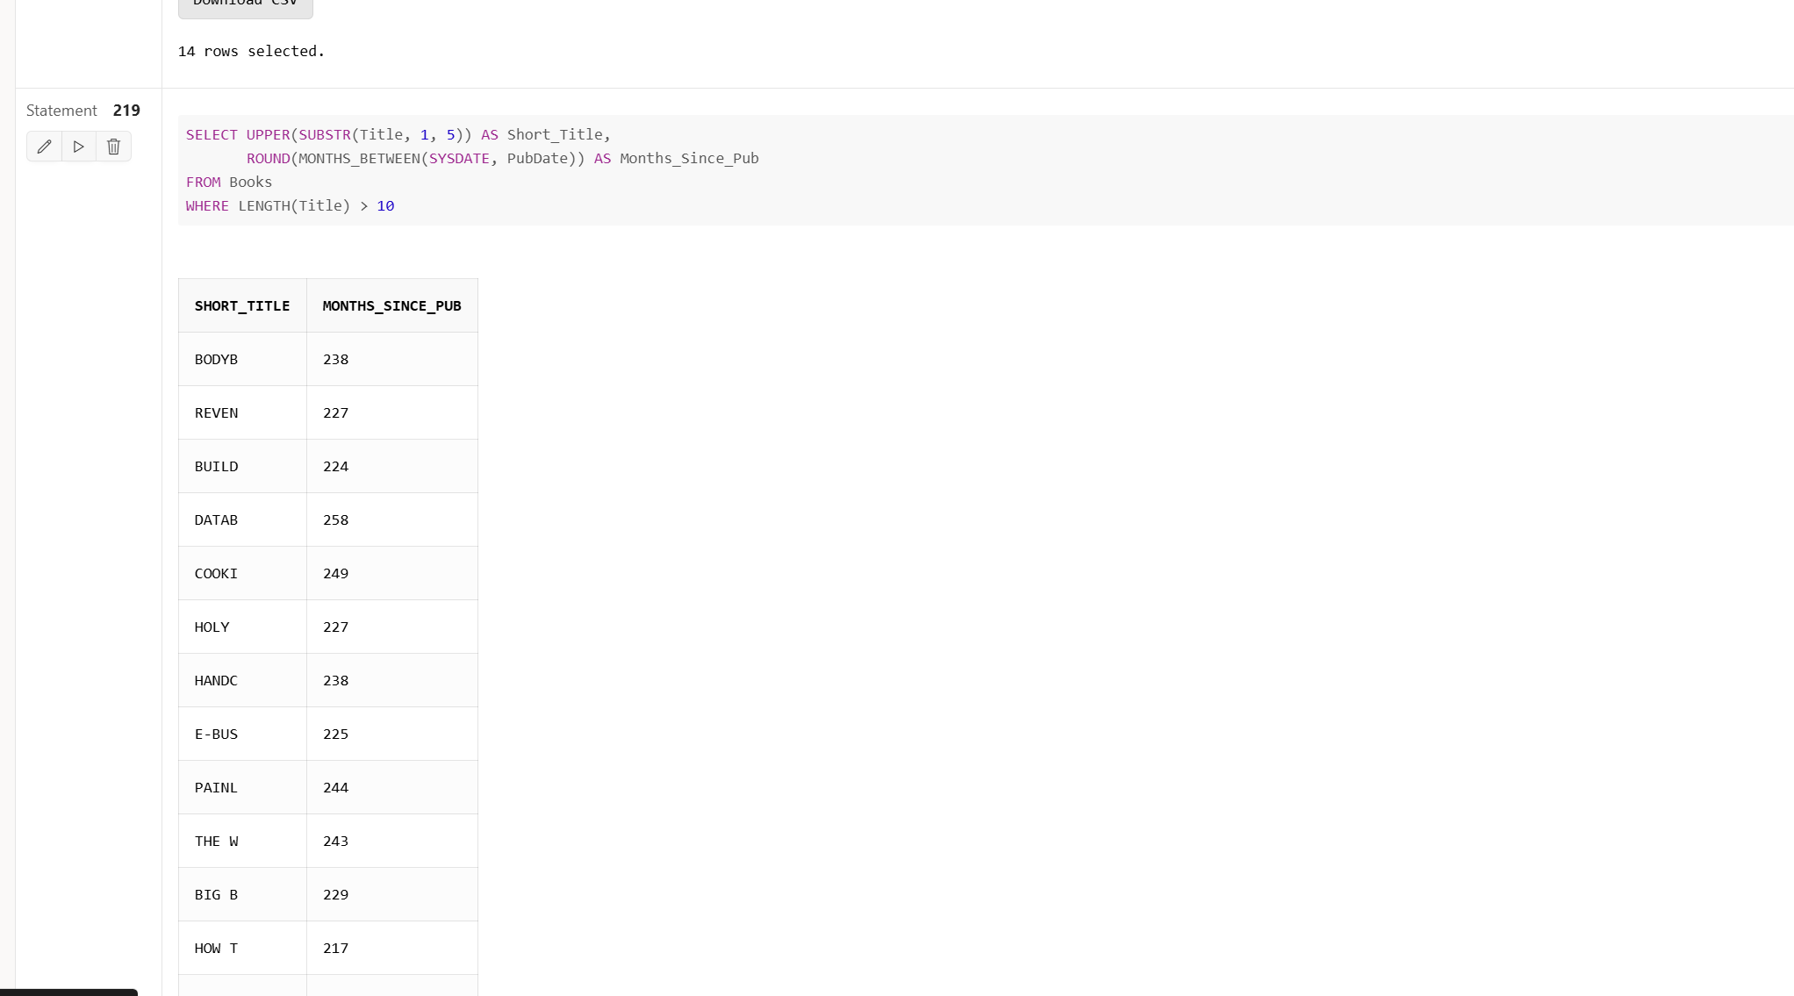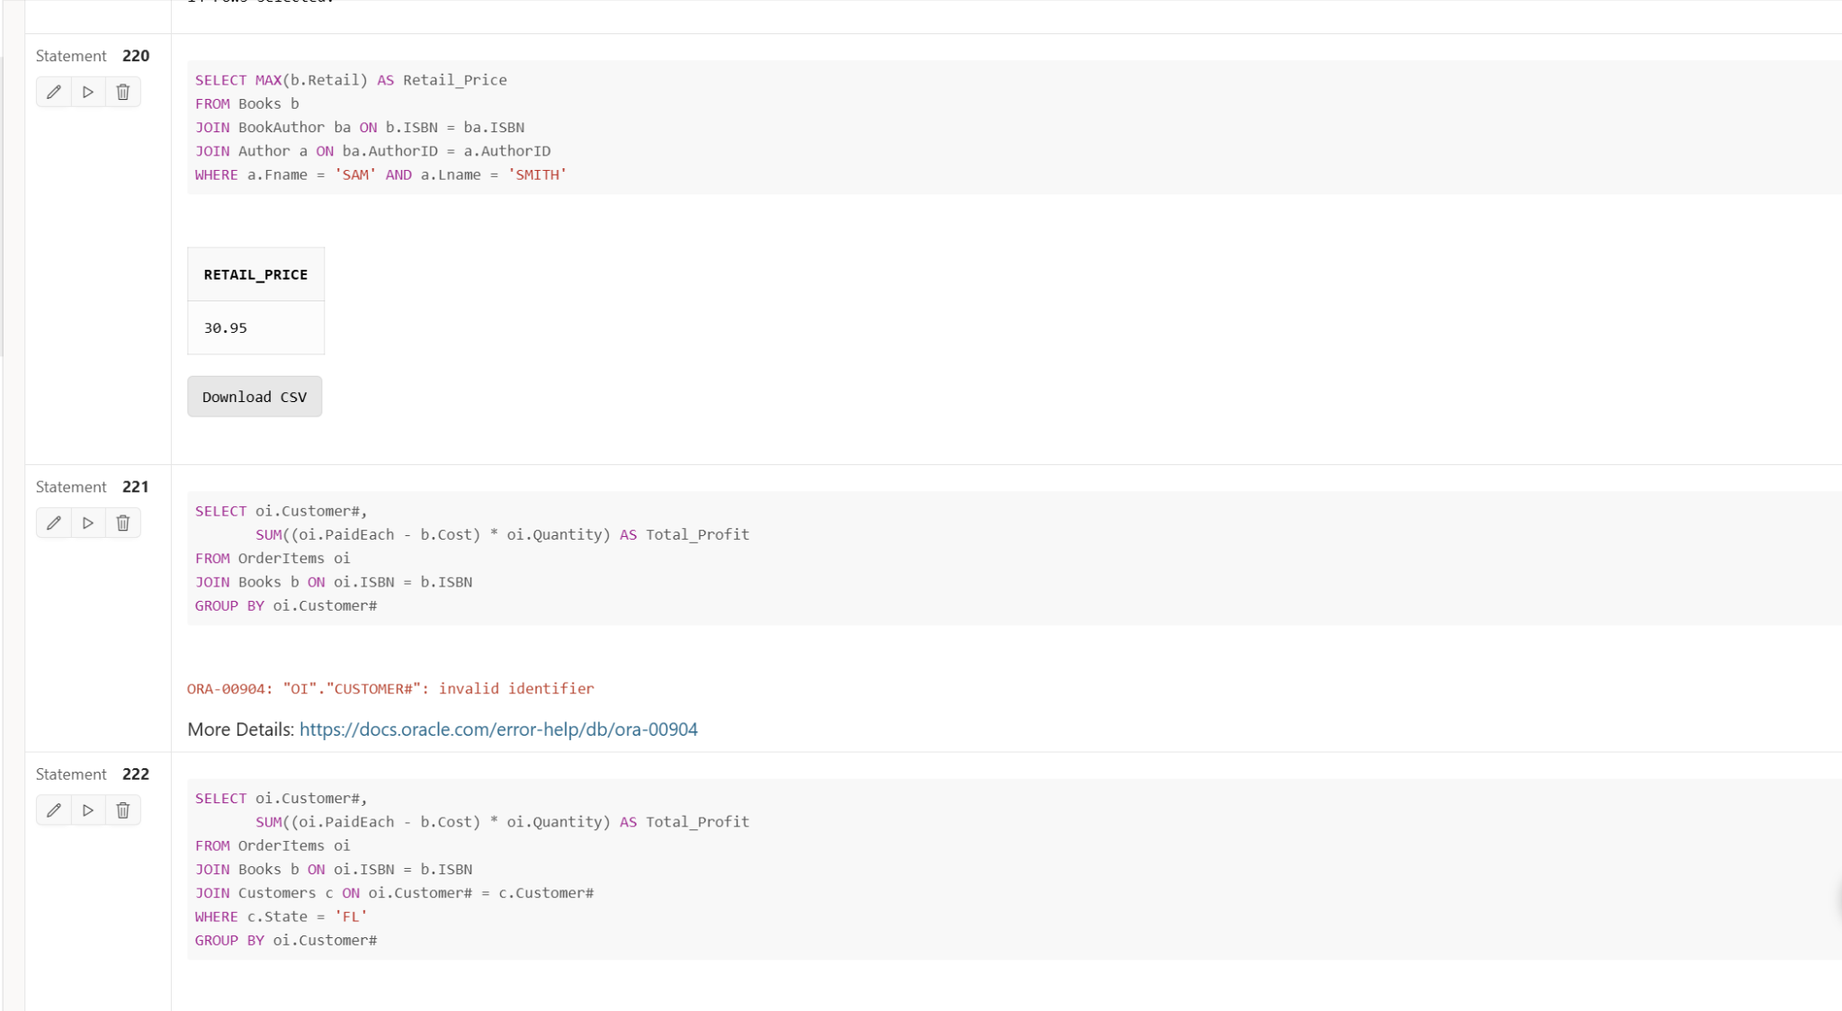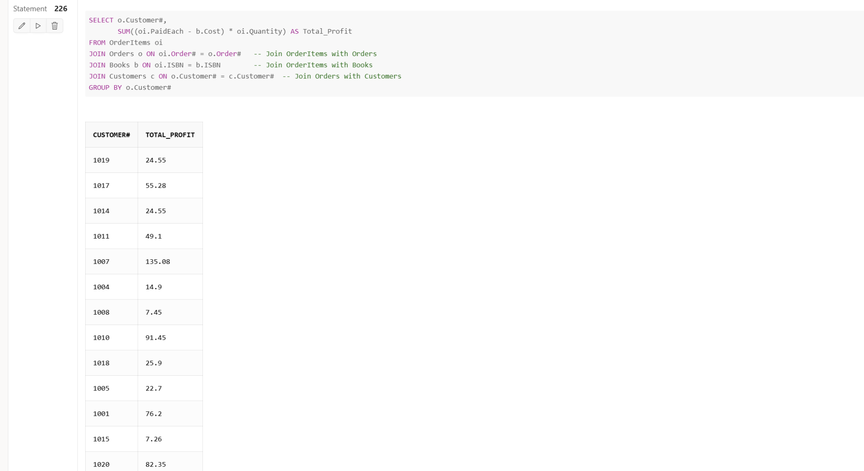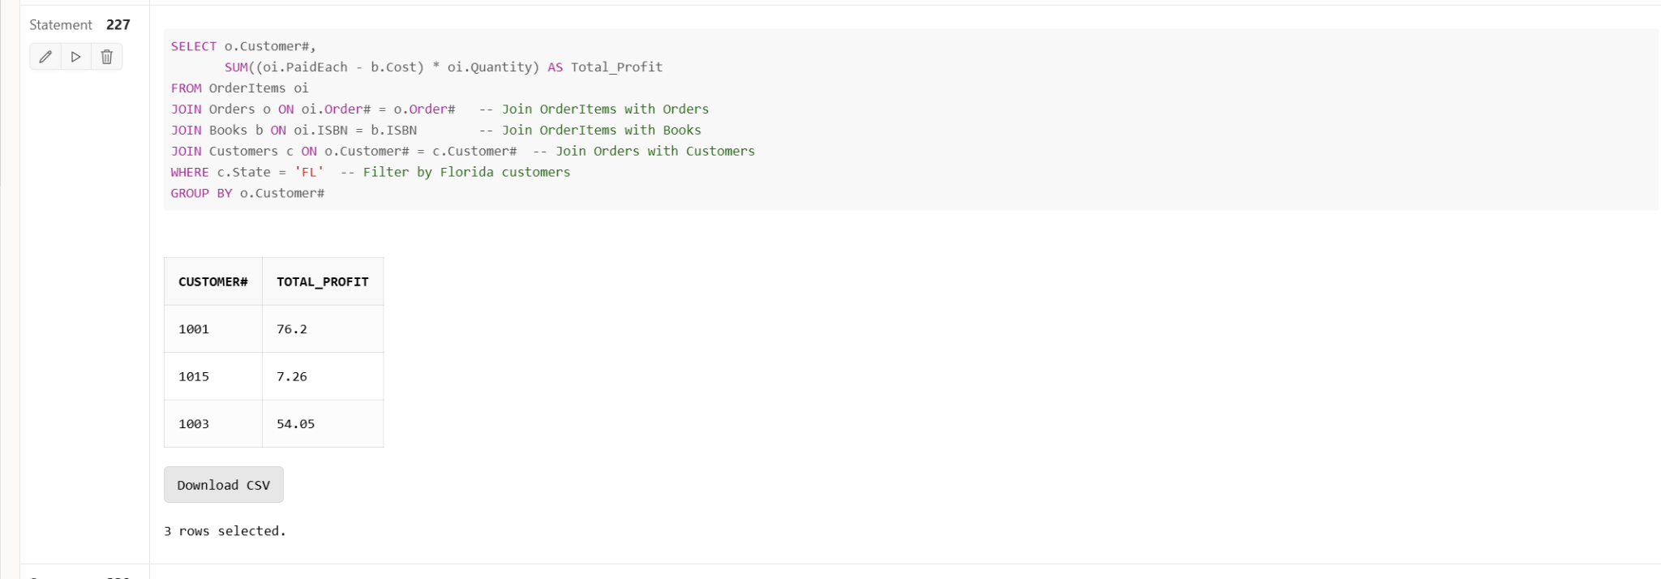

### **SQL Queries and Solutions**

**For each problem, list the SQL query, followed by a brief explanation. Then, include a screenshot showing the executed query and its output (this is the important part for documentation).**

**Example Format:**

#### **1. Display full name using CONCAT**

**Query:  
sql  
  
SELECT 'Chrissie Raj' AS full_name FROM dual;**

* + **Explanation: This query combines the first name and last name into a single string using the CONCAT function.**

#### **2. Using INSTR to find the position of the space**

**Query:  
sql  
  
SELECT INSTR('Chrissie Raj', ' ') AS space_position FROM dual;**

* + **Explanation: This query finds the position of the space in the string 'Chrissie Raj' using the INSTR function.**

#### **3. Extracting the last name with SUBSTR**

**Query:  
sql  
  
SELECT SUBSTR('Chrissie Raj', INSTR('Chrissie Raj', ' ') + 1) AS last_name FROM dual;**

* + **Explanation: The SUBSTR function extracts the substring after the first space, which represents the last name.**

#### **4. Extracting the first name with INSTR and SUBSTR**

**Query:  
sql  
  
SELECT SUBSTR('Chrissie Raj', 1, INSTR('Chrissie Raj', ' ') - 1) AS first_name FROM dual;**

* + **Explanation: This query extracts the first name from the string 'Chrissie Raj' using INSTR to locate the space and SUBSTR to extract the characters before the space.**

#### **5. List all book titles with authors and markup percentage**

**Query:  
sql  
  
SELECT a.Lname || ', ' || a.Fname AS author,**

**b.Title,**

**ROUND(((b.Retail - b.Cost) / b.Cost) * 100, 0) || '%' AS markup_percentage**

**FROM Books b**

**JOIN BookAuthor ba ON b.ISBN = ba.ISBN**

**JOIN Author a ON ba.AuthorID = a.AuthorID;**

* + **Explanation: This query retrieves book titles and authors’ names formatted as 'Last name, First name'. It also calculates the markup percentage as the difference between the retail price and the cost price, expressed as a percentage.**

### **3. Group Functions and Aggregation Queries**

**Continue with the group function problems, providing the SQL queries, explanations, and screenshots for each.**

**For example:**

#### **6. Calculate the total profit for a book purchased on order 1002**

**Query:  
sql  
  
SELECT b.Title,**

**ROUND(SUM((oi.PaidEach - b.Cost) * oi.Quantity), 2) AS profit**

**FROM OrderItems oi**

**JOIN Books b ON oi.ISBN = b.ISBN**

**WHERE oi.Order# = 1002**

**GROUP BY b.Title;**

* + **Explanation: This query calculates the total profit for the book purchased in order 1002 by subtracting the cost from the paid price and multiplying by the quantity. The result is rounded to two decimal places.**

### **4. Final Query (Complex Query with Nested Functions)**

**Provide the final complex query that uses multiple nested functions.**

#### **7. Complex query with multiple nested functions**

**Query:  
sql  
  
SELECT UPPER(SUBSTR(Title, 1, 5)) AS Short_Title,**

**ROUND(MONTHS_BETWEEN(SYSDATE, PubDate)) AS Months_Since_Pub**

**FROM Books**

**WHERE LENGTH(Title) > 10;**

* + **Explanation: This query extracts the first 5 characters of the book title, converts them to uppercase, and calculates the number of months between the current date and the publication date of books with titles longer than 10 characters.**